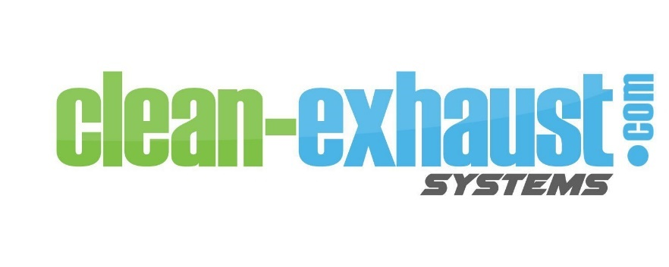
Patent Official #20130283768

MANUAL

Operating Instructions Pages 2-5
EPA Approval Page 6
First Aid Page 6
SDS Sheet for ecoBrew™ N-1 Pages 7-12
ProMinent Solenoid Metering Pump Beta Pages 13-18
Tubing Specifications Page 19
Parts List Page 20
Example of Installations Page 21
What is Diesel Particulate? Page 22-25
Chemical Components found in Diesel Exhaust Page 26
Notes Page 27

For technical support and ecoBrew™

Contact
Captain Ted Sputh, President
+1-317-445-3873
Fax +1-877-792-8363

Capt.ted@clean-exhaust.com

www.clean-exhaust.com

peace of mind is available to all yachts with clean-exhaust service and support

Sept 2019
The ProMinent BetaR is a microprocessor-fed diaphragm solenoid metering pump. The Feed Rate is determined by Stroke Length and Stroke Frequency. The Stroke Length is adjusted from 0% to 100% with a 10:1 turndown. It is highly recommended by the clean-exhaust Crew that the Stroke Length does not go below 30%. The Stroke Frequency is the number of pulses per minute adjusted in 10% increments from 10-100 with an external contact input for pulse control with a range of 1:64-64:1. The BetaR bR can be simply adjusted during operation.

Fuel hose should be used on this system due to temperature fluctuation and psi indications. (specifications tubing/ fuel hose are on page 19)

The delivery of ecoBrew™ should be directly into the cooling water line fresh out of the heat exchangers as far up the line from the spray ring or elbow as possible. This should be done in such a way that when the pump is off, the ecoBrew™ drains naturally into the cooling line from the top. A check valve outside of the pump is not necessary. The system is designed for the ecoBrew™ to drain naturally into the line.

For maximum immediate results from clean-exhaust, a comprehensive cleaning of the vessel’s exhaust system by an exhaust specialist is recommended.

Some vessels have filled their exhaust system with ecoBrew™ to clean the system.
Pipe cleaning with ecoBrew$™$ N1

“I thought I would share the photos of the exhaust cleaning we did. The first picture is before cleaning then the second is after 48hours of the entire exhaust line being filled with one bottle of ecoBrew™ (sitting for 48 hours with no movement in the pipes) the 3rd one is after manual cleaning by hand. I am sure that if there was a circulation going through the pipe it would have given an even better result.”

Captain David Pott

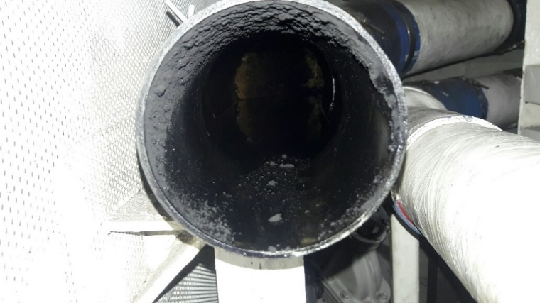
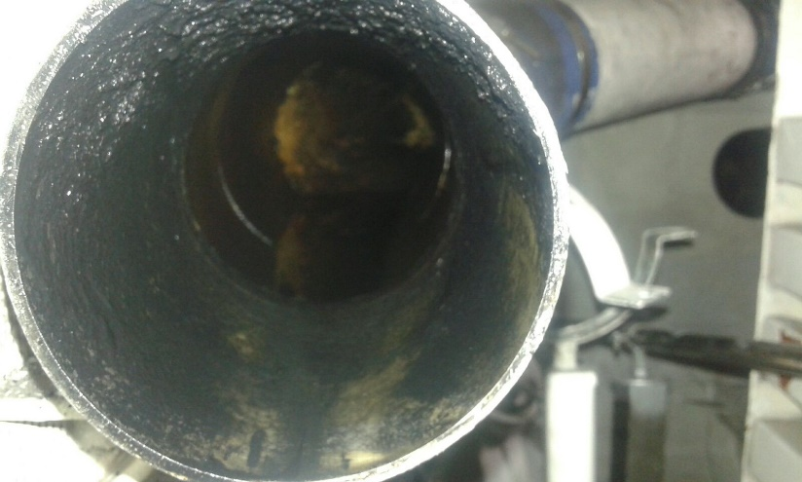

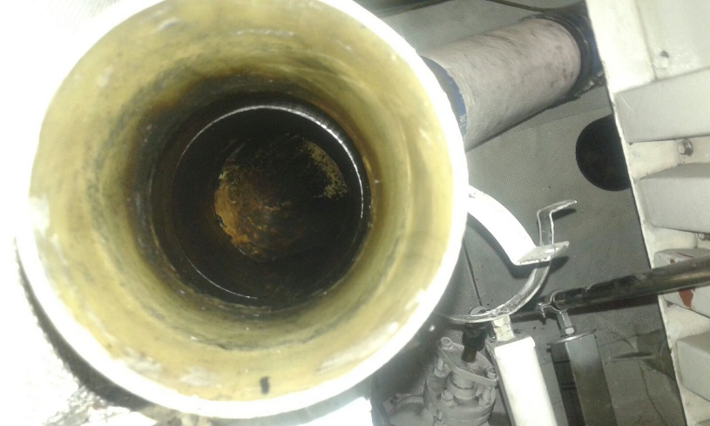

When the system is first turned on, all vessels will see an immediate difference in particulate and discharge in the surrounding water. If an initial cleaning is not done, clean-exhaust needs about 3 months to be fully functional. We attribute this to cleaning the vessel’s entire exhaust system. Some vessels have experienced an oily discharge and flakes for the first few months with some of the residue being a tarlike substance. After the initial cleaning, two things will happen…
- The vessel’s exhaust becomes free from noticeable soot
- Less ecoBrew™ will be needed

Full satisfaction with clean-exhaust’s results will not be realized until the vessel’s exhaust system has its initial cleaning.

To adjust clean‐exhaust
- Turn the load to 30% (never use less than a 30% load) and 30 ppm (pulse per minute)

Keep turning up the ppm, 10 ppm at a time, allowing 5 minutes between adjustments until smoke disappears from the vessel’s exhaust and small white bubbles appear in the underwater discharge.
- If 70 ppm is reached and results are not evident, start turning up the % of load dial until results are evident.
- Once the vessel’s exhaust system has no visible smoke and small white bubbles, an additional increase of values might be necessary so clean-exhaust can overcome the immediate discharge and start cleaning the vessel’s exhaust system.
- Maintaining high levels of ecoBrew™ injections are recommended until the vessel’s exhaust system and muffler are totally clean. Some vessels with particularly dirty exhaust systems have used 100% load and 100ppm. This strategy will increase the vessel’s short- term usage of ecoBrew™. Be prepared for this initial high usage.
- For optimum performance, clean-exhaust needs to be on whenever the generator is running. If the generator is running and clean-exhaust is off, the carbon build up will begin a new cycle.

Monthly maintenance

✓ Check the metering diaphragm for damage
✓ Check for firmly fixed hydraulic lines to the liquid end
✓ Check for a correctly seated section valve and discharge valve
✓ Check the tightness of the entire liquid end…particularly around the leakage hole
✓ Check for correct flow: Allow the pump to prime briefly then turn the multifunctional switch to “Test”
✓ Check for intact electrical connections
✓ Check the integrity of the housing
✓ Check for tight dosing head screws

Per MARPOL Annex V Amendments October 2012
“Cleaning agents and additives used in washing down decks and hulls may be discharged into the sea provided that they are not harmful to the marine environment. Products considered suitable for discharge are those which are not defined as a harmful substance by the criteria set out in MARPOL Annex III and do not contain any carcinogenic, mutagenic or repro-toxic components. In addition, ships will need to maintain records showing that any cleaning agent or additive used was not harmful to the marine environment. IMO recommends that the supplier provides a signed and dated statement to their effect, either as part of a Material Safety Data Sheet (MSDS) or as a stand‐alone document.”
MARPOL Annex III and V
Approved March 2015

Note: ecoBrew™ is an agent that is not harmful to the marine environment

The US EPA states, “The ingredients in ecoBrew meet the EPA’s Safer choice standards.”
- performs well
- cost-effective
- non-toxic
- non-flammable
- biodegradable
- safe for the environment

Product Specifications:
- Container – 1 gallon to be mixed with 3 gallons of fresh water
- Color – Blue
- Fragrance – None
- pH – 11.0 – 11.3
- Viscosity – Water thin (<50cps)
- Foaming – Moderate
- Biodegradable – Complete
- Solubility in Water – 100%
- Weight per Gallon – 8.40 pounds
- Two Year Shelf Life

FIRST AID:
GENERAL: Remove contaminated clothing. SKIN: Wash affected areas thoroughly with soap and water. If irritation develops, seek medical attention. EYES: In case of contact with the eyes, rinse immediately for at least 15 minutes with plenty of fresh water. If irritation develops, seek medical attention. INGESTION: Rinse mouth and then drink plenty of water. Induce vomiting. Never induce vomiting or give anything by mouth if the victim is unconscious or having convulsions. Immediate medical attention required. INHALATION: Remove the affected individual into fresh air and keep the person calm. Assist in breathing if necessary. Immediate medical attention required.

Safety Data Sheet
Date of issue 20 May 2017
1. PRODUCT AND COMPANY IDENTIFICATION
Product identifier
Product Name |  |  |  | ecoBrew N-1
Other means of identification
SDS# |  |  |  | JC-022-019
Details of the supplier of the safety data sheet
Company Name | Clean Exhaust Systems, Inc.  8403 N Illinois  Indianapolis, IN 46260

Emergency telephone number
Emergency Telephone |  |  |  | INFOTRAC 1-800-535-5053
2. HAZARDS IDENTIFICATION
Classification
OSHA Regulatory Status
This product has been classified in accordance with the 2012 OSHA Hazard Communication Standard (29 CFR 1910.1200)
Acute toxicity - Oral |  |  |  |  |  |  |  | Not classified
Acute toxicity - Dermal |  |  |  |  |  |  |  | Not classified
Label elements
Emergency Overview
Appearance Clear | Physical state Liquid | Odor Typical

Precautionary Statements - Response
Immediately call a POISON CENTER or doctor/physician
Specific Treatment (See Section 4 on the SDS)
IF SWALLOWED: Rinse mouth. DO NOT induce vomiting
Immediately call a POISON CENTER or doctor/physician
Drink plenty of water
Precautionary Statements - Disposal
Disposal should be in accordance with applicable regional, national and local laws and regulations
Hazards not otherwise classified (HNOC)
Other Information
Unknown Acute Toxicity |  |  |  | 5.004% of the mixture consists of ingredient(s) of unknown toxicity
3. COMPOSITION/INFORMATION ON INGREDIENTS
Chemical Name |  |  |  |  | CAS No. |  | Weight-% |  |  | Trade Secret
Fatty Alcohols, C12-14,Ethoxylated, Propoxylated |  |  |  |  | 68439-51-0 |  | 10-30 |  |  | *
*The exact percentage (concentration) of composition has been withheld as a trade secret.
4. FIRST AID MEASURES
First aid measures

Eye contact |  |  |  | Rinse thoroughly with plenty of water for at least 15 minutes, lifting lower and upper eyelids. Consult a physician.
Inhalation |  |  |  | Remove to fresh air.
Ingestion |  |  |  | Clean mouth with water and drink afterwards plenty of water.
Most important symptoms and effects, both acute and delayed

Symptoms |  |  |  | Any additional important symptoms and effects are described in Section 11: Toxicology Information.
Indication of any immediate medical attention and special treatment needed

Note to physicians |  |  |  | Treat symptomatically.
5. FIRE-FIGHTING MEASURES
Suitable extinguishing media
Use extinguishing measures that are appropriate to local circumstances and the surrounding environment.
 | Unsuitable extinguishing media |  |  | Caution: Use of water spray when fighting fire may be inefficient.
Specific hazards arising from the chemical
No Information available.
 | Explosion data
 | Sensitivity to Mechanical Impact |  |  | None.
 | Sensitivity to Static Discharge |  |  | None.
Protective equipment and precautions for firefighters
As in any fire, wear self-contained breathing apparatus pressure-demand, MSHA/NIOSH (approved or equivalent) and full protective gear.
6. ACCIDENTAL RELEASE MEASURES
Personal precautions, protective equipment and emergency procedures
Personal precautions |  |  |  | Ensure adequate ventilation, especially in confined areas.
Environmental precautions
Environmental precautions |  |  |  | See Section 12 for additional ecological information.
Methods and material for containment and cleaning up
Methods for containment |  |  |  | Prevent further leakage or spillage if safe to do so.
Methods for cleaning up |  |  |  | Pick up and transfer to properly labeled containers.
7. HANDLING AND STORAGE
Precautions for safe handling

Advice on safe handling |  |  |  | Handle in accordance with good industrial hygiene and safety practice.
Conditions for safe storage, including any incompatibilities

Storage Conditions |  |  |  | Keep containers tightly closed in a dry, cool and well-ventilated place.
Incompatible materials |  |  |  | None known based on information supplied.
8. EXPOSURE CONTROLS/PERSONAL PROTECTION
Control parameters
Exposure Guidelines |  |  |  | This product, as supplied, does not contain any hazardous materials with occupational exposure limits established by the region specific regulatory bodies.
Appropriate engineering controls

Engineering Controls |  |  |  | Showers, Eyewash stations & Ventilation systems.
Individual protection measures, such as personal protective equipment

 | Eye/face protection |  |  | No Information available. Avoid contact with eyes.
 | Skin and body protection |  |  | No Information available. Wear protective gloves and protective clothing if needed.
 | Respiratory protection |  |  | If exposure limits are exceeded or irritation is experienced, NIOSH/MSHA approved respiratory protection should be worn. Positive-pressure supplied air respirators may be required for high airborne contaminant concentrations. Respiratory protection must be provided in accordance with current local regulations.
General Hygiene |  |  |  | Handle in accordance with good industrial hygiene and safety practice.
9. PHYSICAL AND CHEMICAL PROPERTIES
Information on basic physical and chemical properties

Physical state |  |  |  | Liquid
Appearance | Clear

Color | Blue

Odor | Typical

Odor threshold | No Information available

Property Values |  |  |  |  |  |  | Remarks • Method
 | pH | 11.0-11.3

 | Specific Gravity | 1.0134

 | Viscosity | No Information available

 | Melting point/freezing point | No Information available

 | Flash point | Above 200°F

 | Boiling point / boiling range | >= 100 °C / 212 ° F (at 760 mm Hg)

 | Evaporation rate | No Information available

 | Flammability (solid, gas) | No data available

Flammability Limits in Air

 | Upper flammability limit: | No Information available

 | Lower flammability limit: | No Information available

 | Vapor pressure | No Information available

 | Vapor density | No Information available

 | Water solubility | Complete

 | Partition coefficient | No Information available

 | Autoignition temperature | No Information available

 | Decomposition temperature | No Information available

Other Information

 | Density Lbs/Gal |  |  | 9.2
 | VOC Content (%) |  |  | No Information available
10. STABILITY AND REACTIVITY
Reactivity
No data available

Chemical stability
Stable under recommended storage conditions.
Possibility of Hazardous Reactions
None under normal processing.
Conditions to avoid
Extremes of temperature and direct sunlight.
Incompatible materials
None known based on information supplied.
Hazardous Decomposition Products
None known based on information supplied.
11. TOXICOLOGICAL INFORMATION
Information on likely routes of exposure
Product Information
 | Inhalation |  |  | No data available. Avoid breathing vapors or mists.
 | Eye contact |  |  | No data available. Avoid contact with eyes.
 | Skin Contact |  |  | No data available. Prolonged or repeated contact may dry skin and cause irritation.
 | Ingestion |  |  | No data available. Not an expected route of exposure. Do not taste or swallow.
Chemical Name |  |  | Oral LD50 |  |  | Dermal LD50 |  |  | Inhalation LC50
Fatty Alcohols, C12-14,Ethoxylated, Propoxylated  68439-51-0 |  |  | = 3530 mg/kg ( Rat ) |  |  | - |  |  | -
Information on toxicological effects
Symptoms |  |  |  | No Information available.
Delayed and immediate effects as well as chronic effects from short and long-term exposure
Sensitization |  |  |  | No Information available.
Germ cell mutagenicity |  |  |  | No Information available.
Carcinogenicity |  |  |  | No Information available.
Reproductive toxicity |  |  |  | No Information available.
STOT - single exposure |  |  |  | No Information available.
STOT - repeated exposure |  |  |  | No Information available.
Aspiration hazard |  |  |  | No Information available.
Numerical measures of toxicity - Product Information
Unknown Acute Toxicity |  |  |  | 5.004% of the mixture consists of ingredient(s) of unknown toxicity
The following values are calculated based on chapter 3.1 of the GHS document .
 | ATEmix (oral) |  |  | 18,933.00 mg/kg
12. ECOLOGICAL INFORMATION
Ecotoxicity
7.26% of the mixture consists of components(s) of unknown hazards to the aquatic environment
Persistence and degradability
No Information available.
Bioaccumulation
No Information available.
Other adverse effects |  |  |  | No Information available
13. DISPOSAL CONSIDERATIONS
Waste treatment methods

Disposal of wastes |  |  |  | Disposal should be in accordance with applicable regional, national and local laws and regulations.
Contaminated packaging |  |  |  | Do not reuse container.
14. TRANSPORT INFORMATION
The basic description below is specific to the container size. This information is provided for at a glance DOT information. Please refer to the container and/or shipping papers for the appropriate shipping description before tendering this material for shipment. For additional information, please contact the distributor listed in section 1 of this SDS.
DOT |  |  |  | Not regulated
15. REGULATORY INFORMATION
International Inventories
TSCA |  |  |  | Complies
DSL/NDSL |  |  |  | Complies
Legend:
TSCA - United States Toxic Substances Control Act Section 8(b) Inventory
DSL/NDSL - Canadian Domestic Substances List/Non-Domestic Substances List
US Federal Regulations
SARA 313
Section 313 of Title III of the Superfund Amendments and Reauthorization Act of 1986 (SARA). This product does not contain any chemicals which are subject to the reporting requirements of the Act and Title 40 of the Code of Federal Regulations, Part 372
SARA 311/312 Hazard Categories
 | Acute health hazard |  |  |  |  | No
 | Chronic Health Hazard |  |  |  |  | No
 | Fire hazard |  |  |  |  | No
 | Sudden release of pressure hazard |  |  |  |  | No
 | Reactive Hazard |  |  |  |  | No
CWA (Clean Water Act)
This product does not contain any substances regulated as pollutants pursuant to the Clean Water Act (40 CFR 122.21 and 40 CFR 122.42)
CERCLA
This material, as supplied, does not contain any substances regulated as hazardous substances under the Comprehensive Environmental Response Compensation and Liability Act (CERCLA) (40 CFR 302) or the Superfund Amendments and Reauthorization Act (SARA) (40 CFR 355). There may be specific reporting requirements at the local, regional, or state level pertaining to releases of this material
US State Regulations
California Proposition 65
This product does not contain any Proposition 65 chemicals
U.S. State Right-to-Know Regulations

U.S. EPA Label Information
EPA Pesticide Registration Number |  |  |  | Not Applicable
16. OTHER INFORMATION
NFPA |  | Health hazards 0 |  |  | Flammability 0 |  | Instability 0 |  |  | Physical and Chemical Properties Yes
HMIS |  | Health hazards 0 |  |  | Flammability 0 |  | Physical hazards 0 |  |  | Personal protection X
Issue Date |  |  |  | 20-May-2017
Revision Date |  |  |  | 20-May-2017
Revision Note
No Information available
Disclaimer
The information provided in this Safety Data Sheet is correct to the best of our knowledge, information and belief at the date of its publication. The information given is designed only as a guidance for safe handling, use, processing, storage, transportation, disposal and release and is not to be considered a warranty or quality specification. The information relates only to the specific material designated and may not be valid for such material used in combination with any other materials or in any process, unless specified in the text.
End of Safety Data Sheet

ProMinent Solenoid Metering Pump Beta 1000

To see full manual on line visit

http://prominent.us/promx/pdf/986356_ba_be_026_04-12_en_beta-b_en_low.pdf

NOTE: The clean-exhaust ProMinent pump has a high working pressure of 145 psi or 10 bar

Note: Installation of the dosing pump should be in a location that is below the injection point on the engine to avoid any possibility of forming a syphon in the unlikely event of a malfunction of the pump’s check valves.

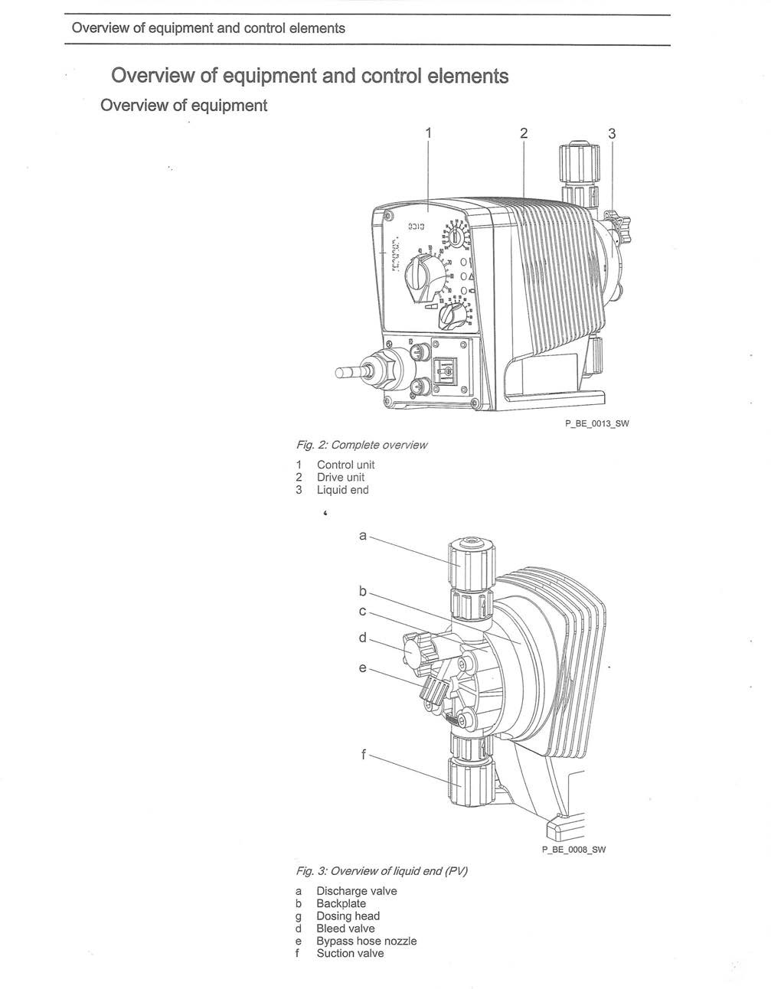

Overview of equipment and control elements

Control elements

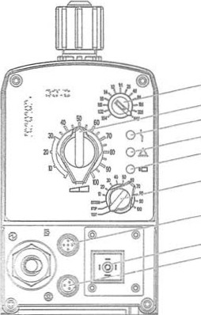
2
3
4
5
6

7

8
9
P_ee_oo11_sw

Fig. 4
- Pulse Control Switch
- Stroke length adjustment knob
- Fault indicator (red)
- Warning indicator (yellow)
- Operating indicator (green)
- Multi- functional switch
- External control terminal
- Relay connection (optional)
- Level Switch terminal

Pulse Control Switch

Extern Contact operating mode via the pulse control switch a single contact (at the "external control" terminal) can be used to trigger a series of strokes or to support an incoming series of contacts.

Stroke length adjustment knob
The stroke length adjustment knob can be used to adjust the stroke llllll

Multifunctional switch

The multi-function switch can be used to set the following functions, operating modes and stroke rate.
The operating modes that can be set are:
Test (priming function)
Stop
Extern (Contact)
Manual (setting stroke rate in 10 % increments)

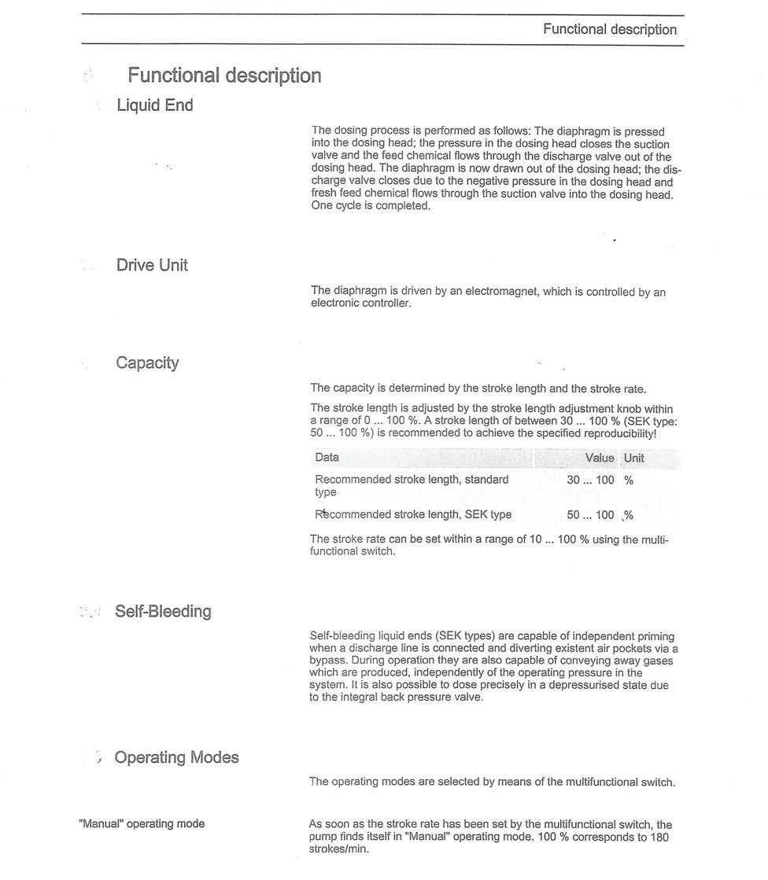

16
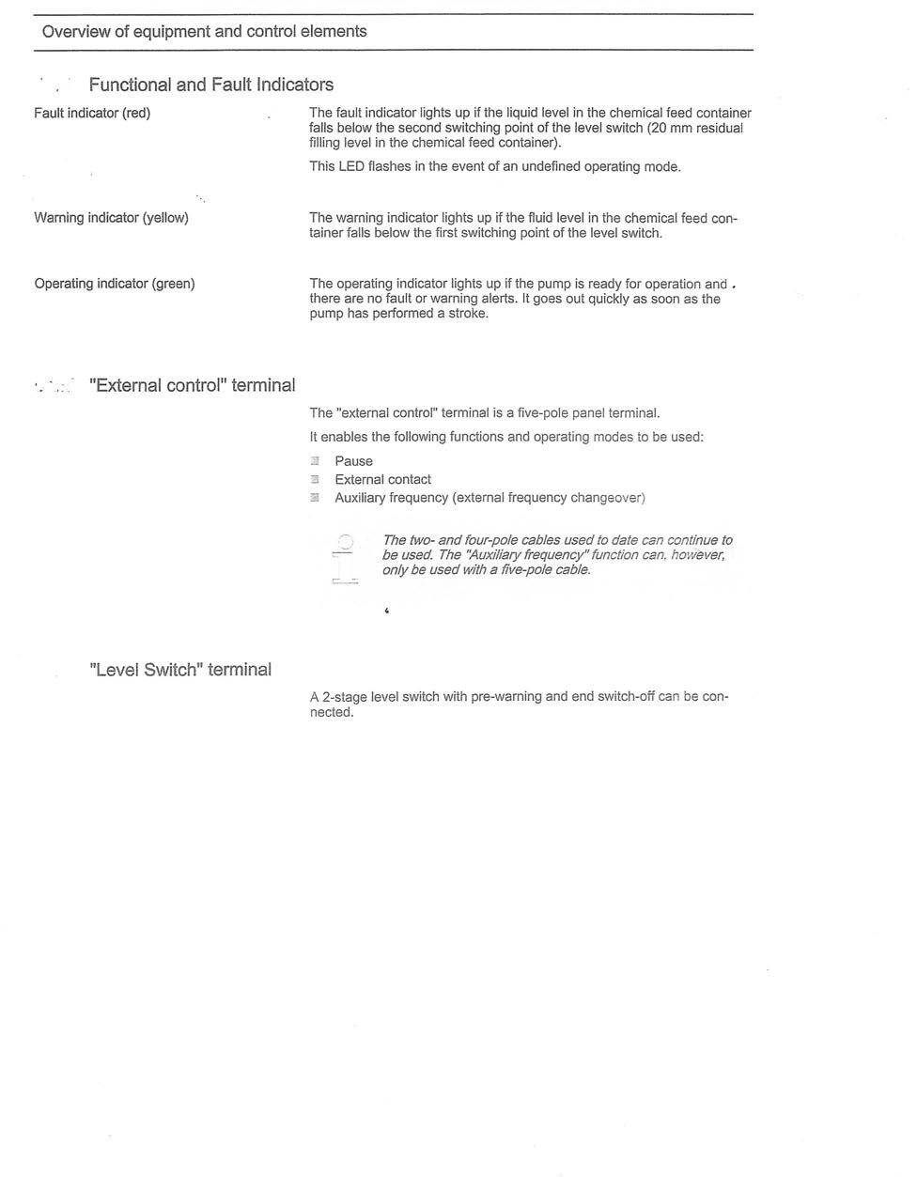
17

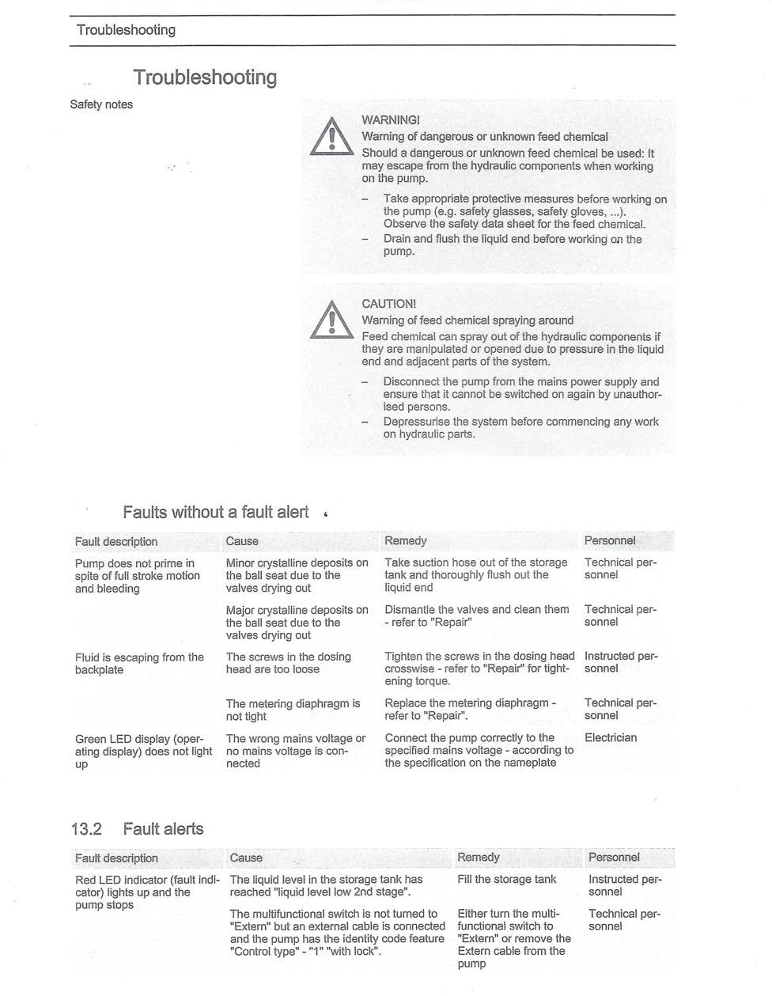

18
clean-exhaust tubing

A1-15 EPA & CARB COMPLIANT FUEL LINE

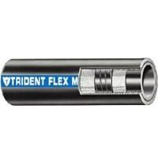

# 365 Series
Trident Barrier Lined A1-15 Fuel Hose for both gasoline (including ethanol blends) and diesel
(including bio diesel blends). The #365 series exceeds ABYC H-24 & H-33, SAE J1527, ISO 7840,
USCG Type A1-15; CARB Executive Order and EPA Certified low permeation Type A1-15; and is
NMMA Type Accepted & CE certified. This hose is built with the best fuel, fire and age resistant
formulation and a unique "Barrier Liner" on inside surface of the tube, so fuel is not in direct
contact with rubber. Provides extraordinary resistance to fuel permeation, aging, and also to fire,
heat, cold, and the ozone. Also provides excellent bend-ability.

Specifications

Construction:
Tube: Nylon Internal Barrier, NBR
Cover: NBR/PVC Blend
Reinforcement: Polyester 2 spiral
Lengths: 250’ (76 m), and 500’ (152 m) Reels, 100’ (30.5 m), 50’ (15 m), and 25’ (7.6 m) Boxed
ID: .25 inch
OD Burst Pressure: 810 psi
Working Pressure: 100 psi
Temperature Range: -20 F to 212 F (-28 C to 100 C)

19

clean-exhaust
Parts List

Metering Pump Beta #100
Two Stage Float Switch 095
Pump Repair Kit 652
Vent Valve 365
Knob for Vent Screw 832
Ceramic Weight for Float Switch 004
External Control Cable 6’ 300
Fault Indicating Relay 311
Flex Tubing Trident A1-15

For replacement or warranty issues contact

Ted Sputh
Capt.ted@clean-exhaust.com
+1 317 445 3873
Fax +1 877 792 8363

2 year clean-exhaust warranty on all parts
Warranty is void if ecoBrew™ is not used in the system or installation pictures are not presented to the clean-exhaust office if system is self- installed

20

3 possible clean-exhaust installations…feasible installations are endless

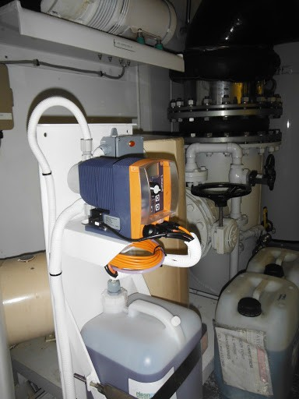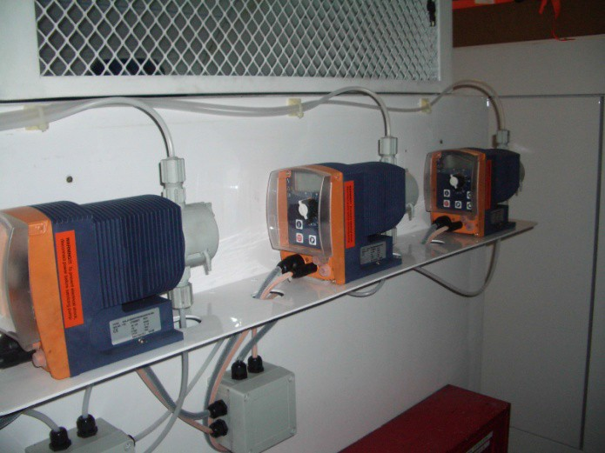

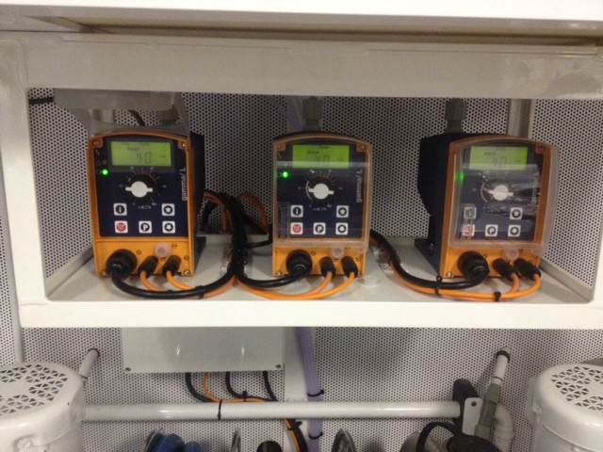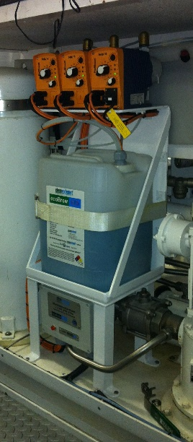

clean-exhaust the green solution to marine diesel exhaust pollution

The clean-exhaust crew wishes you fair winds, calm seas, and clean exhaust

21
A PARTICULATE PROBLEM
Mr. Rudolf Diesel invented the diesel engine in 1893. One hundred and twenty-two years later, a super yacht Captain and Engineer found Mr. Diesel’s engine idea to be genius but observed that it created less than a clean burn with massive amounts of diesel particulate being expelled into the air and water. In the effort to create a solution for a problem, they devised a way of cleaning diesel exhaust by injecting an emulsifier into the generator’s raw water cooling system via a dosing pump just before the spray ring cleaning the petro fuel exhaust with the projected result of little or no particulate being expelled in the gas exhaust. During the first days of use, the inventors thought their system was ill conceived because there was an increase in the expulsion of diesel particulate. Then, they realized that their system was cleaning the muffler and the piping of exhaust build up. After the initial cleaning, like magic, the exhaust particulate began to disappear. Unlike Mr. Diesel, whose first attempt to build an internal combustion engine almost killed him when it exploded, no human or known marine life has been harmed with the Captain and Engineer’s clean-exhaust invention.
In 2014, the following clean-exhaust emulsifier test was conducted…Both the starboard and the port sides of 164’ mega yacht with two 130kW generators were washed. Once the hull was dry, blue tape was applied to a 3’ x 3’ area in close proximity to the exhaust. The vessel’s generators were running with the clean-exhaust system working in tandem for 3 days. The blue tape was then removed revealing no black soot residue evident on the blue tape or on a white glove slide across the hull. The generators continued to run and the clean-exhaust system was turned off for 18 hours with no emulsifier running. The 1st mate of the vessel declared the clean-exhaust results to be “irrefutable” that “without the clean-exhaust system turned on, the soot and diesel emissions into the atmosphere, clinging to the hull, and going into the water were quite prevalent”. The emulsifier which later became known as ecoBrew™ was given the Environmental Protection Agency (EPA) Design for the Environment Seal of Approval and then the coveted MARPOL approval after 10,000 hours of run time in development. The entire system has received a patent.
A 100kW Tier 2 certified diesel generator operating under optimum conditions, may legally discharge 720 grams of particulate per day or more than one and a half pounds of particulate per generator can legally be expelled into our air, our respiratory systems, our oceans, and our waterways. This mobile particulate represents a mixture of fine, ultrafine, and nano particles which carry sulfates, nitrates, organic compounds, elemental carbon and metal compounds that can remain in the atmosphere for days and travel hundreds to thousands of kilometers. Their rough irregular surface makes it easy for them to bind with other toxins in the environment increasing their noxious effects on everything in their path.
In the EPA’s 2002 Diesel Health Assessment Document, exposure to diesel exhaust was classified as likely to be carcinogenic to humans by inhalation from environmental exposures. A number of other agencies including the National Institute for Occupational Safety and Health, the International Agency for Research on Cancer, the World Health Organization, the California EPA, and the United States Department of Human Services have made similar classifications.
An estimated 158,040 Americans died from lung cancer in 2015. The majority of this cancer is attributed to cigarette smoke particulate. About 16,000 to 24,000 Americans die of lung cancer even though they have never smoked. Diesel exhaust contains more than 40 toxic air
22
contaminants. These include many known or suspected cancer- causing substances such as benzene, arsenic and formaldehyde. Long term exposure to diesel exhaust particles pose the highest cancer risk of any toxic air contaminant evaluated by the Office of Environmental Health Hazard Assessment at CA.gov.
About 14% of all new cancers are lung cancers. The American Cancer Society estimates 234,030 new cases of lung cancer will be diagnosed in 2018. The average age of diagnosis is 70. Let’s give our Crews the opportunity to breathe clean air while they are young. They might just thank you when they are 70!
The United States military coined an expression in World War II, “Smoke ‘em if you got ‘em” and then seconds later, the Sergeant would yell, “Now, put ‘em out!” This phase referred to taking a break and smoking cigarettes. The Sergeant might have saved some lives with his quick command to “put’em out”. The expression holds true today for those smokin’ exhaust systems… “put ‘em out”. Insist on clean-exhaust.com
Being involved in the yachting industry is not just a job for most, it is a way of life. Do not be lulled into complacency thinking that the exhaust from vessels can’t be cleaned. Be proactive about the air that we breathe, the waters that we love and the hulls that we clean.

Captain Ted Sputh,
President, clean-exhaust.com
For more information +1 317 445 3873

What is Particulate Matter?
What is Particulate Matter?
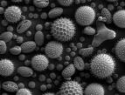
Most people have no idea what particulate matter (PM) is, let alone, that there is such a thing as particle pollution. We might think that pollution is just "something that floats in the sky way above our head" or that it is far away because it can only be seen in the distance. This thinking is wrong, in fact, pollution surrounds us no matter where we are or what we’re doing. Even on a clear day it’s everywhere, in the atmosphere, at ground level, and yes, even in our homes. Particulate matter floats through the air and with every breath we take we breathe it in, and most of it isn't visible to the naked eye. Although so small as to be invisible, PM is the air pollution that most commonly affects people’s health.
23
Particle pollution is produced in a great number of ways that can be classified into either
mechanical or chemical processes. The mechanical process of particle pollution involves the breaking down of bigger matter into smaller particles without the material changing, only becoming smaller. Agriculture, coal and oil combustions, dust storms and construction are some activities that produce many of the larger or coarse particles. The chemical process of particle formation can be from sources that burn fuel and emit gases. Here, the pollutant vaporizes and then condenses to become a particle of the same chemical compound. The small particles can further react or combine with other compounds in the atmosphere. A major source for particles formed this way are the burning of fossil fuels in industry, transportation, agriculture, etc.
Particles come in many, many shapes and sizes, and can be solid particles or liquid droplets. The size of particles is directly linked to their potential for causing health problems. Traditionally, the environmental sciences have divided particles into two main groups and these two groups are different in many ways. PM10 is particles between 2.5 and 10 microns (micrometers) in diameter (a human hair is about 60 micron in diameter). PM2.5 is particles smaller than 2.5 microns. The PM10 and PM2.5 measurements you might have seen reported, by the EPA for example, refer to the total weight of the particle found. This is a holdover from when the available technology had difficulty detecting individual particles. More modern monitoring equipment, such as that used in clean room monitoring, count and size individual particles. The Dylos DC1100 is this more modern type of device and counts individual particles in two size ranges which will roughly correlate to PM2.5 and PM10.
There is more than size that is different in these types of particles. Each type of particle has different material compositions and can come from different places. The smaller the particle the longer it can remain suspended in the air before settling. PM2.5 can stay in the air from hours to weeks and travel very long distances because it is smaller and lighter. PM10 can stay in the air for minutes to hours and can travel shorter distances from hundreds of yards to many mile because it is larger and heavier.
When you inhale, you breathe in air along with any particles that are in the air. This breath of air, along with the particles, travel into your respiratory system, and along the way the particles can stick to the sides of the airway or travel much deeper into the lungs. Your lungs produce mucous to trap particles and there are also tiny hairs (called cilia) that move the mucous and particles out of the lungs. PM2.5 can get down into the deepest (alveolar) portions of the lungs when gas exchange occurs between the air and your blood stream. These are the most dangerous particles because the alveolar portion of the lungs has no efficient means of removing them and if the particles are water soluble, they can pass into the blood stream within minutes. If they are not water soluble, they remain in the alveolar portion of the lungs for a long time.
However, when the small particles go deeply into the lungs and become trapped this can result in lung disease, emphysema and/or lung cancer in some cases. Exercise and physical activity cause people to breather faster and more deeply and to take more particles into their lungs.
24
The United States Environmental Protection Agency reported “studies suggested small particles can leave the lung and travel through the blood to other organs, including the heart”.
The main effects associated with exposure to particulate matter may include: premature mortality, aggravation of respiratory and cardiovascular disease (indicated by increased hospital admissions and emergency room visits, school absences, loss of work days, and restricted activity days) aggravated asthma, acute respiratory symptoms, chronic bronchitis, decreased lung function and increased myocardial infarction. Epidemiologic studies suggest that exposure to particulate matter may result in tens of thousands of excess deaths per year, and many more cases of illness among the US population.
People with heart or lung diseases such as coronary artery disease, congestive heart failure, and asthma or chronic obstructive pulmonary disease (COPD) are at an increased risk, because particles aggravate these diseases. People with diabetes also may be at an increased risk, possibly because they are more likely to have underlying cardiovascular disease, and older people may be at greater risk due to undiagnosed heart or lung disease or diabetes. Infants and children are also at risk for several reasons, first their lungs are still developing and they have an increased level of activity and play. This is when they would be more likely to have asthma or acute respiratory disease, which is aggravated when particle levels are at their highest. It has also been suggested that high exposure to particle levels may attribute to low birth weights in infants, pre-term deliveries and possible fetal and infant deaths.

25
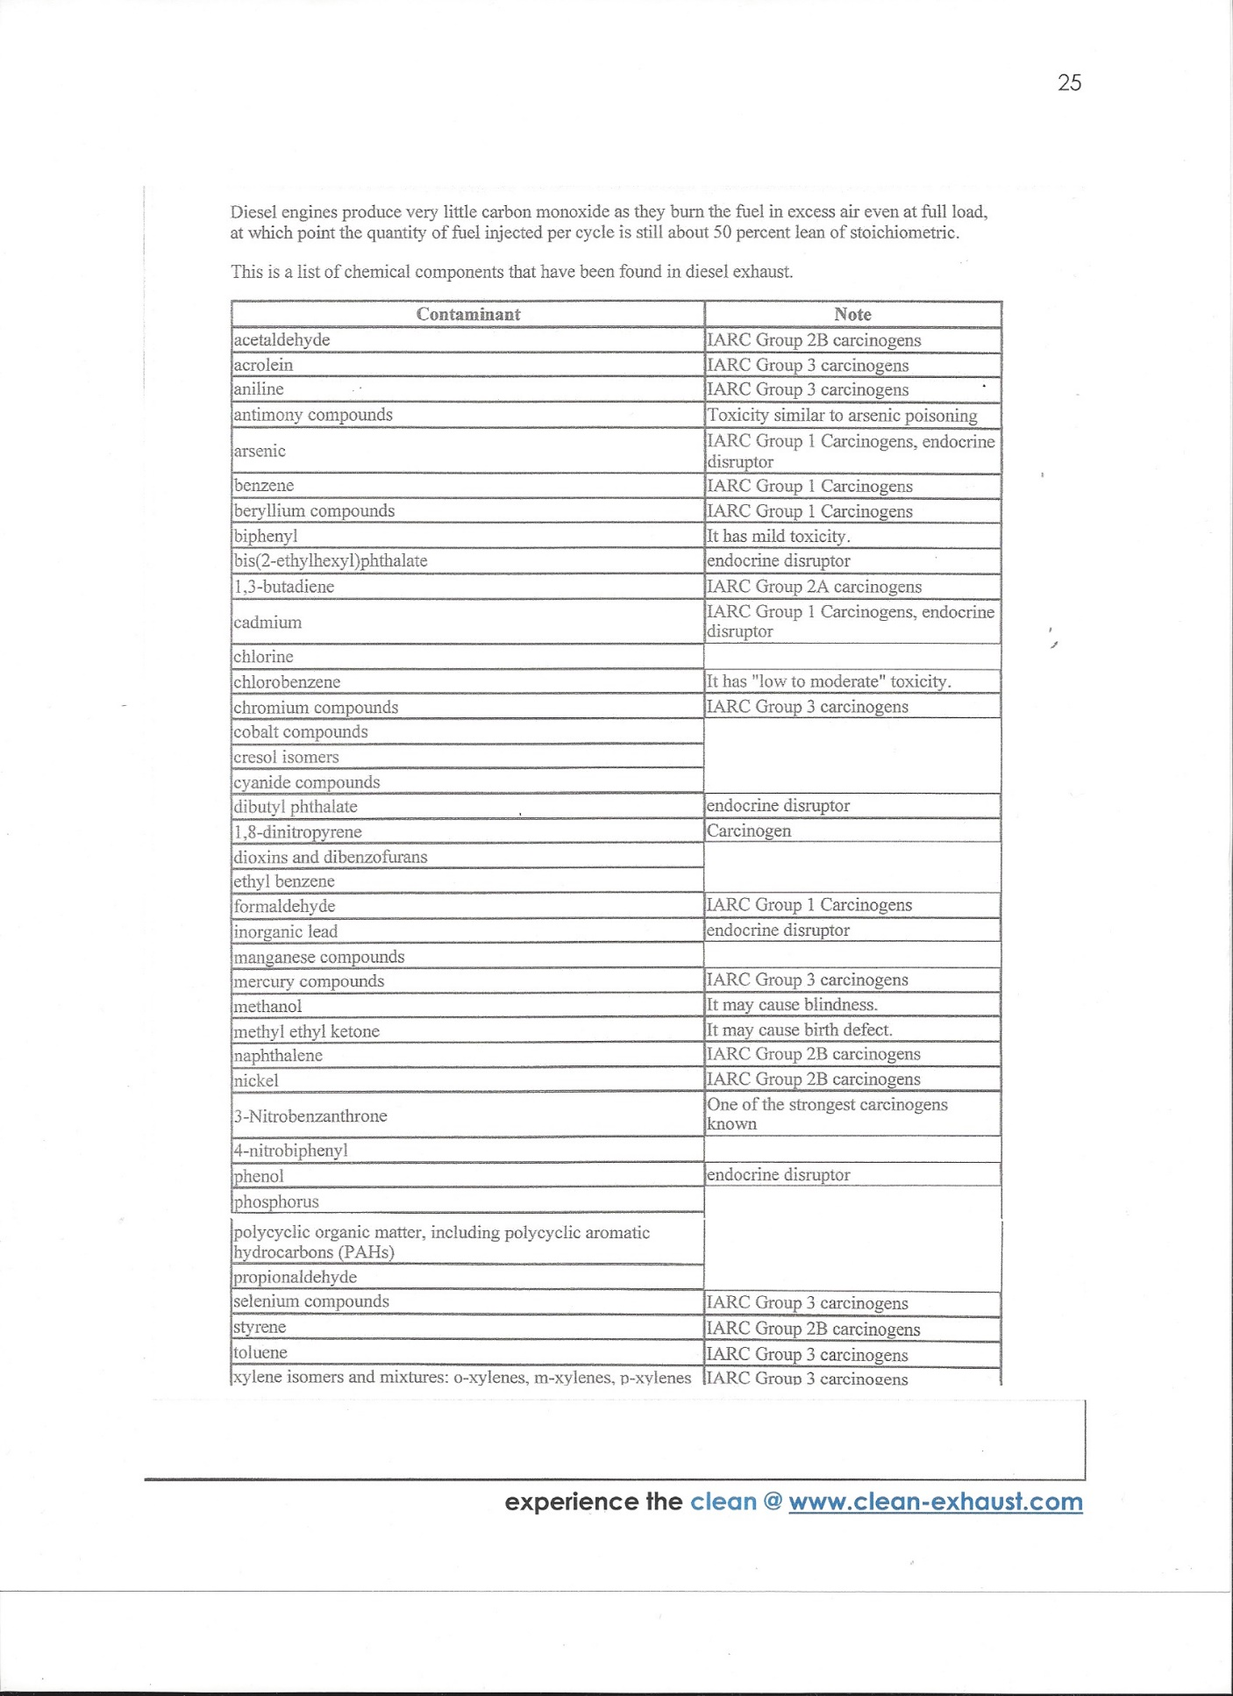
26
NOTES

27

